PUBLIC INFORMATION OFFICER JOB ACTION SHEET
Position Assigned To: _______________________
You Report To:_______________________(Emergency Incident Commander)
Command Center: __________________________
Telephone : (direct)_________________________(extension) _______
MISSION: Provide information to the news media and public.
IMMEDIATE TASKS
- Receive appointment from Emergency Incident Commander.
- Read this entire Job Action sheet and review organizational chart on back.
- Put on position identification vest. Identify restrictions in contents of news release information
- from Emergency Incident Commander.
- Establish a Public Information area away from E.O.C. and patient care activity.
- Ensure that all news releases have the approval of the Emergency Incident Commander.
- Issue an initial incident information report to the news media with the cooperation of the Situation-Status Unit Leader. Relay any pertinent data back to Situation-Status Unit Leader.
- Inform on-site media of the physical areas which they have access to, and those which are restricted. Coordinate with Safety and Security Officer.
- Contact other at-scene agencies to coordinate released information, with respective P.I.0.s. Inform Liaison Officer of action.
EXTENDED TASKS
- Obtain progress reports from Section Chiefs as appropriate.
- Notify media about casualty status.
- Contact Labor Pool to determine requests to be made to the public via the media.
- Direct calls from those who wish to volunteer to Labor Pool.
- Observe all staff, volunteers and patients for signs of stress and inappropriate behavior. Report concerns to Psychological Support Unit Leader. Provide for staff rest periods and relief.
- Other concerns:

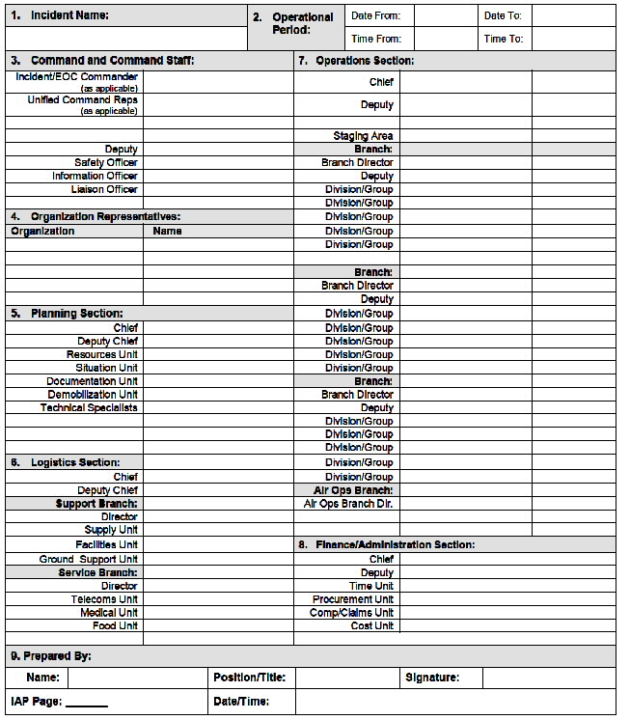
Adapted from Emergency Incident Management Systems: Fundamentals and Applications by Louis N. Moho, Sr. Copyright 2006 by John Wiley & Sons, Inc. and Incident Management System Forms Ontario Ministry of the Solicitor General https://www.emergencymanagementontario.ca/english/emcommunity/ProvincialPrograms/IMS/Resources/IMS_forms/IMS_forms_Annex_C.html accessed 19-3-2021

